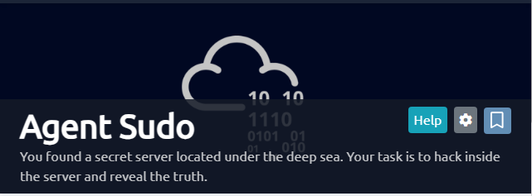

This is a Tryhackme CTF.
We will use the Agent-Sudo machine that we started beforehand and the AttackBox

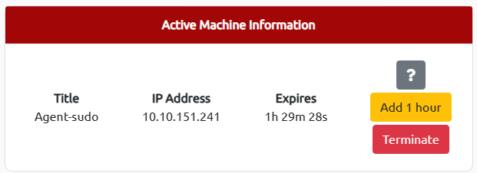

Let’s Go!

In task 1, just click on Completed

Task 2: Enumerate

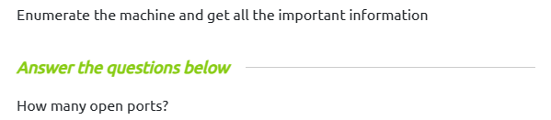

To answer this question we used the command nmap -A -O 10.10.151.241

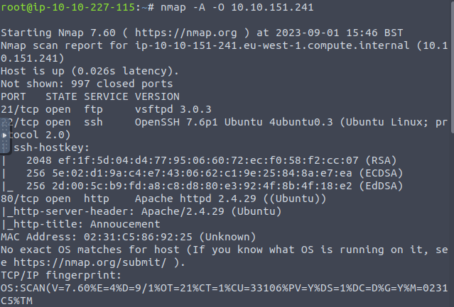

ON found three open ports

We have port 80 which is open with the Apache service running on this port. We therefore have a website on this port. We open the browser and type http://10.10.151.241
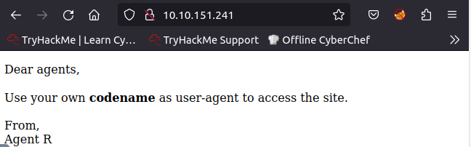

This is what this page shows us

The following question
So the answer is user-agent

To access the secret page we have installed the extension in our browser that will allow us to modify the user-agent
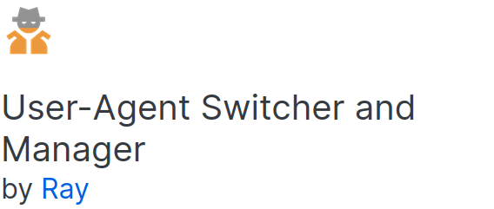

After installing it, open it and in the user-agent part with 'C'. Know that the codename ‘C’ varies depending on each and I click enter.
I go back to the main page of the site, I refresh it and it shows me
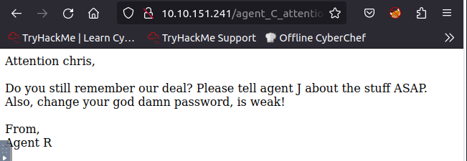

The next question asks for the name of the user-agent . So mine is chris

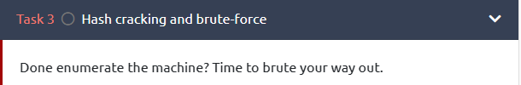

The first instruction asks to find the password of the ftp account

For this I will use the hydra tool. Remember in the secret page agent R asks me to change my password. So I used the hydra command with as username the name of my user-agent which is chris at home with the wordlist rockyou.txt.
hydra -l chris -P /usr/share/wordlists/rockyou.txt ftp://10.10.151.241 -f . The f option is to specify that it stops when it finds the password. I got this

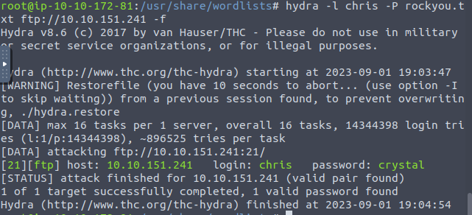

The password is therefore crystal
Using these credentials, I connect to the ftp account with the credentials found in the previous question using the syntax
ftp 10.10.151.241
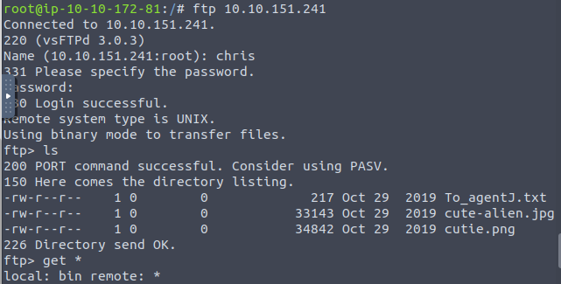

I do an ls and I see that there are three files: a txt file and two images. I decide to download them on my local pc with the command get filename

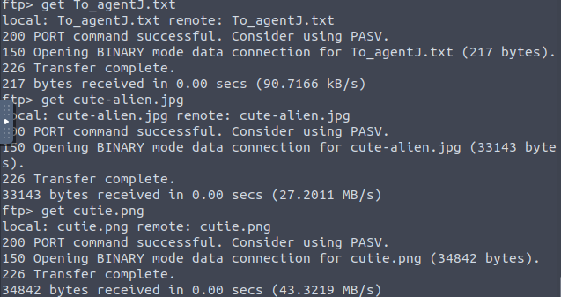
I look at the contents of the To_agentJ.tx file. I open it and look for its contents but I can't find anything. I open the images with Cyberchef to see if they hide information.
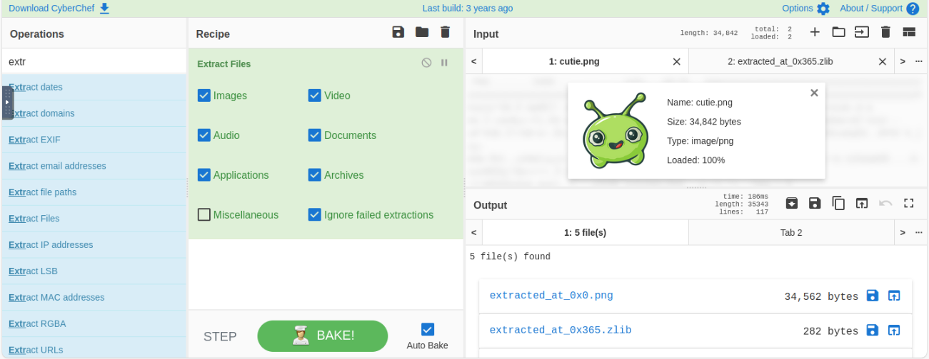

And I see that the cutie.png image contains .zlib folders and a zip folder.
I then download it.

The next question asks us to find the password of the zipped folder. It must be the one we just extracted. To achieve this we will use John The Ripper. First we calculate the hash of the folder with the command and store it in a file.

We then crack this hash.
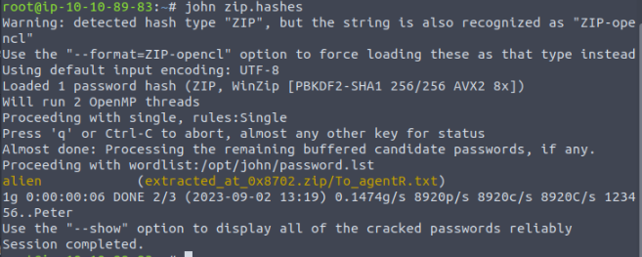
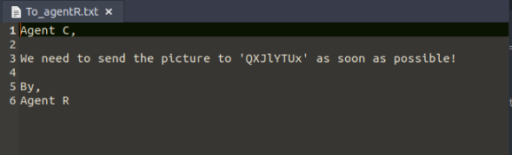
So we have the password which is alien. When I unzip this file I get this message.

The word 'QXJlYTUx' is coded in base 64. I decode it with the online platform dcode and I get:

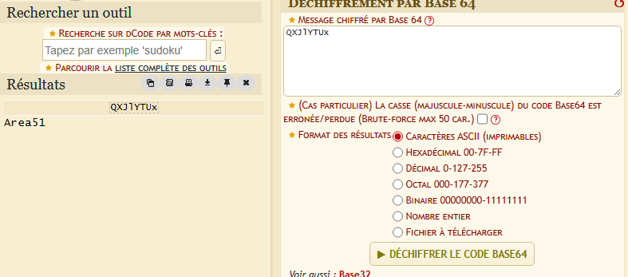

The following question asks us for the password of the steg so it is: Area51

I examine the second image with cyberchef and I extract the information it contains with steghide.

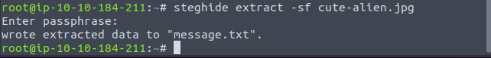
It therefore contains a message.txt file. I open the contents of the file and I get a message containing a login and a password.
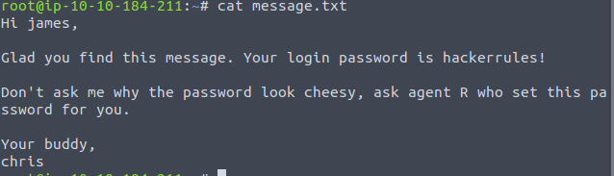

The next question asks us who the other Agent is, so it is james .
And the SSH password is hackerrules.

Task 4:

With these identifiers I connect by ssh with the command ssh james@addressIP.

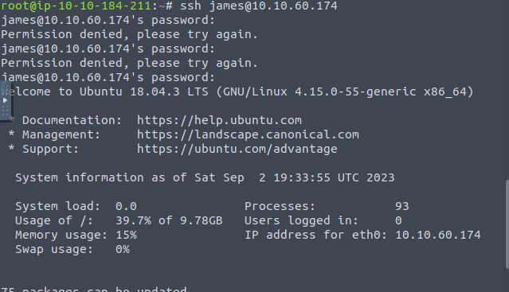
I list the files and directories with the command ls . I get two files: an image and a .txt file

The next question asks for the user flag. I then deduce that the .txt file contains this flag. So I do cat user_flag.txt and I get b03d975e8c92a7c04146cfa7a5a313c7
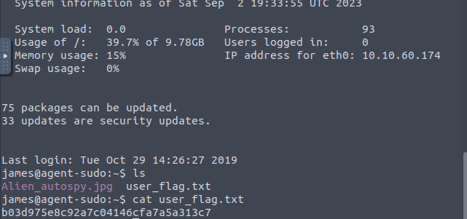
I then upload the image to my machine usingscp
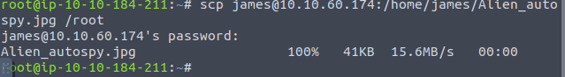

Once in my machine I open it and come across a photo of the autopsy of a corpse. I do a reverse search with the online tool TinEye and I get a title that catches my attention.

The next question asks
What is the incident of the photo called?


It is therefore Roswell alien autopsy.

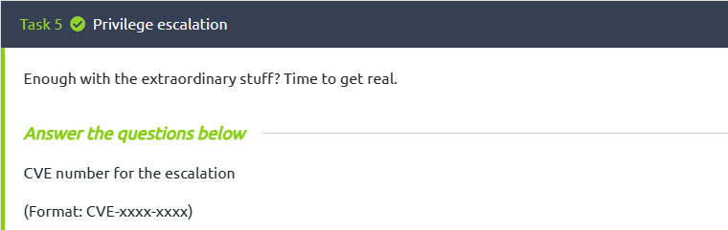

I connect with ssh into the james account again and run the sudo -l command to see all the sudo mode permissions he has
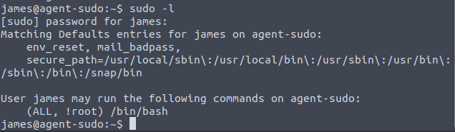

. So I get the rights. I then do a search on Google to find the exploit
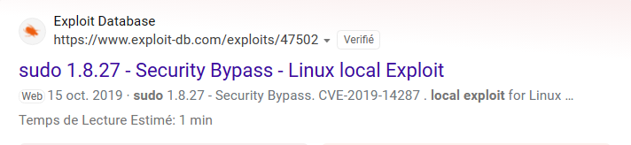
The CVE is therefore CVE-2019-14287

To achieve the exploit, I use the python script found on exploit-db.

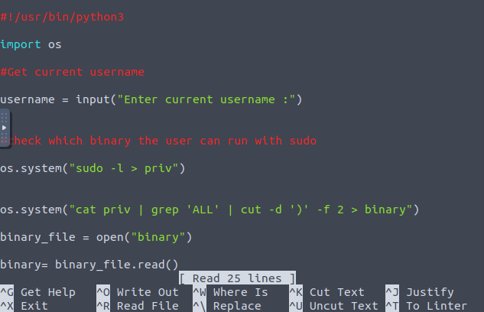

After running it I get

And I run the dir command to see the tree structure and I see that there is a root folder.
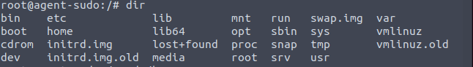
So I go into this folder and find the root.txt file.
The next question asks for the root flag. So that's b53a02f55b57d4439e3341834d70c062

The last question asks for the name of agent R.
L’agent R is DesKel


